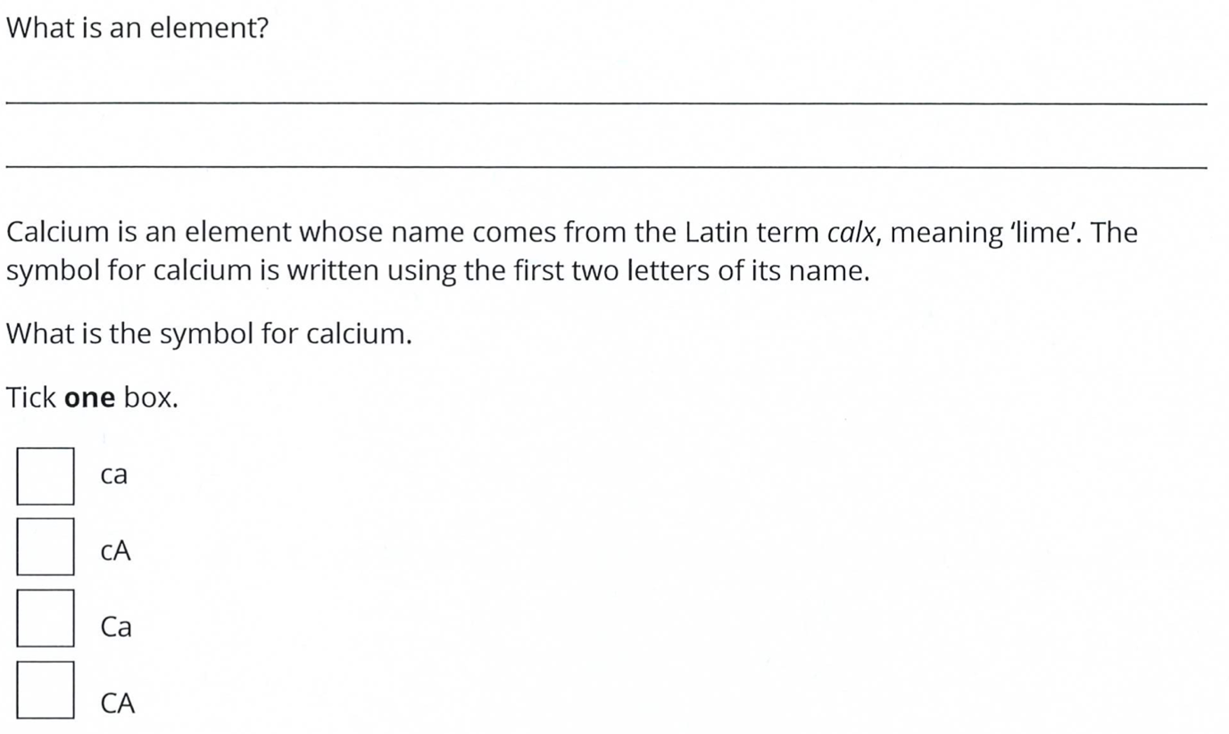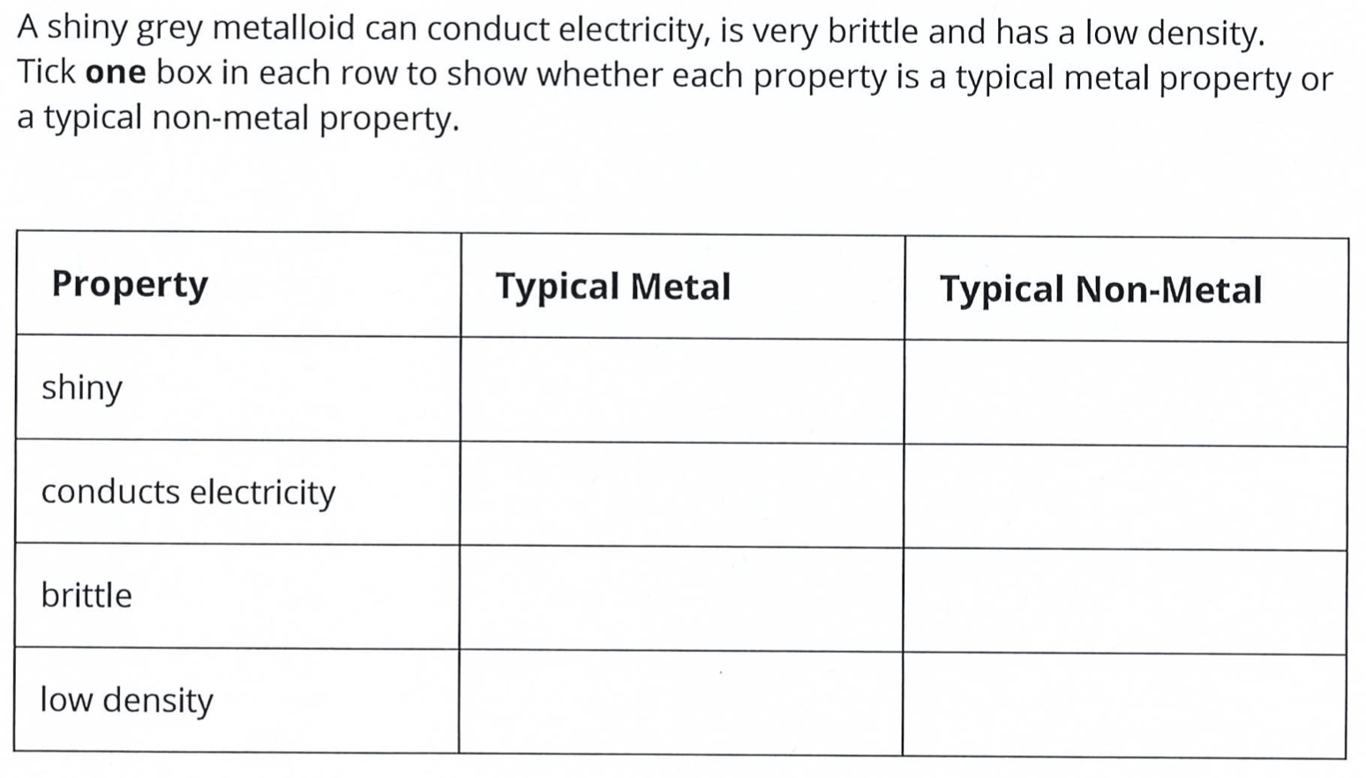
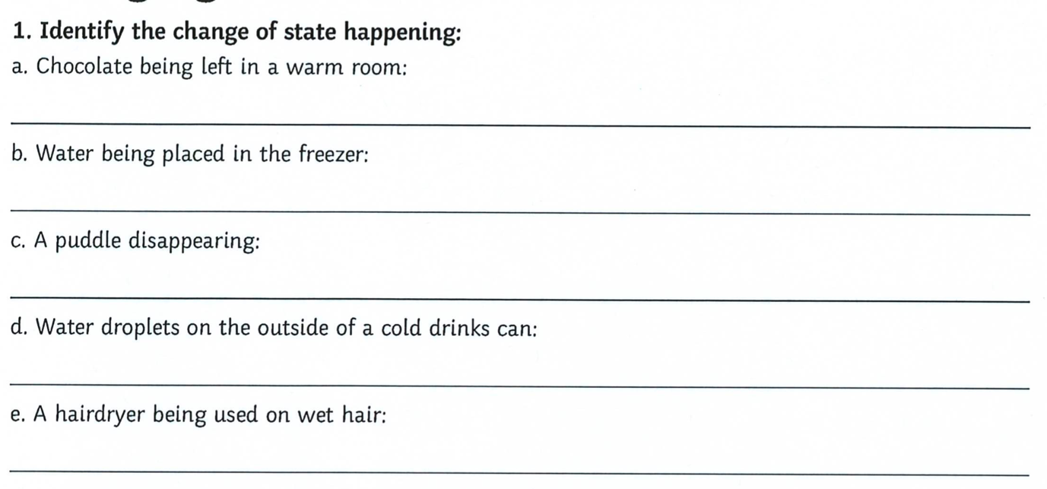
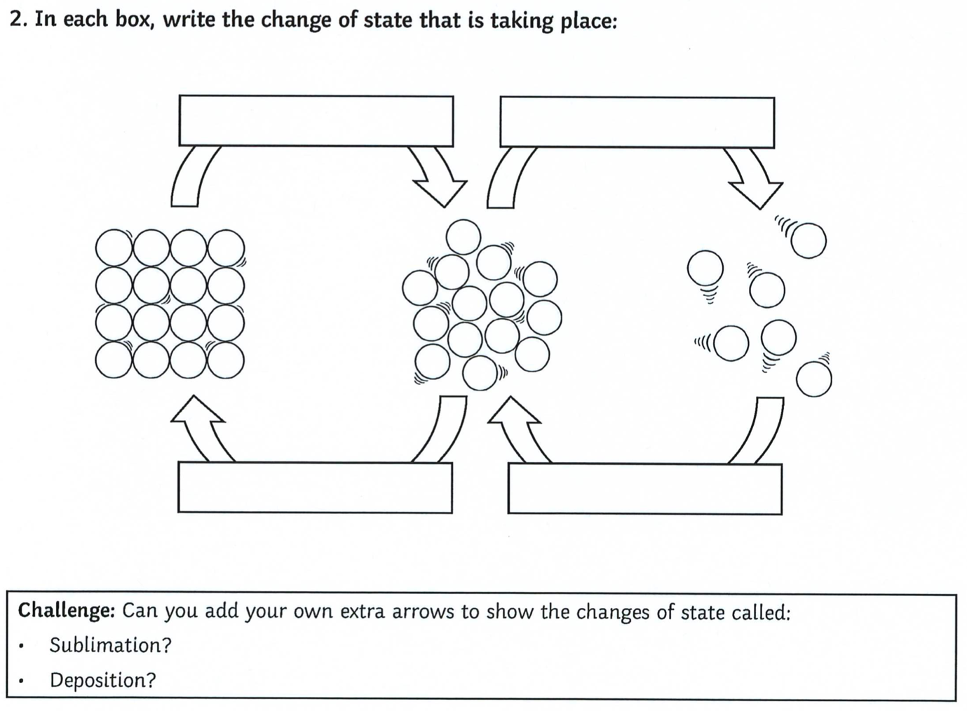
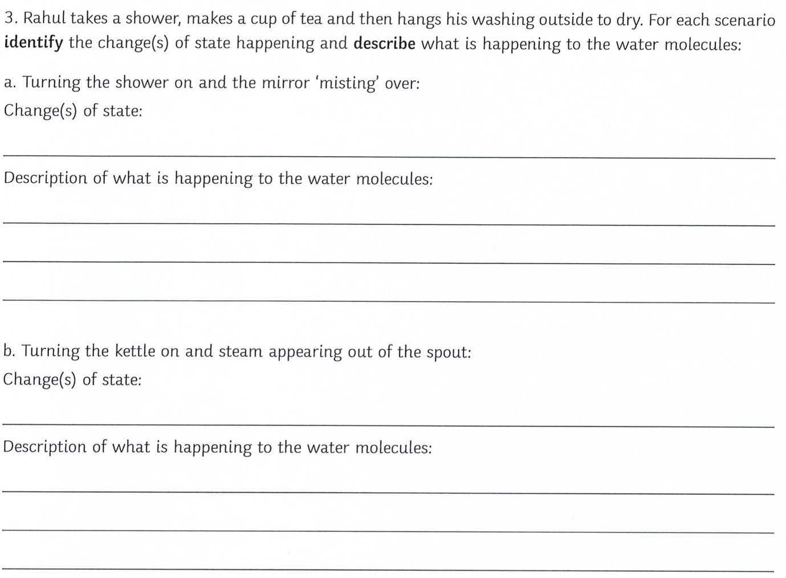
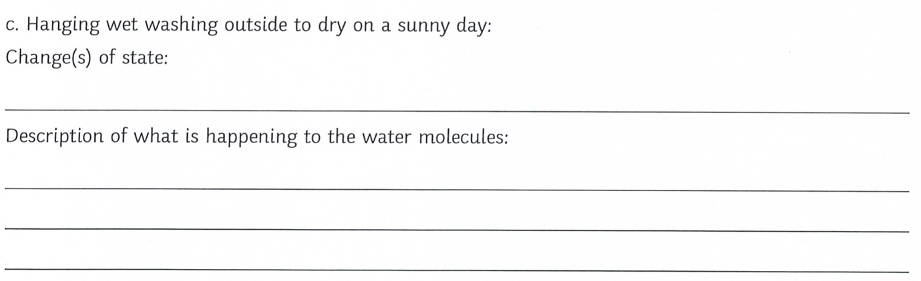
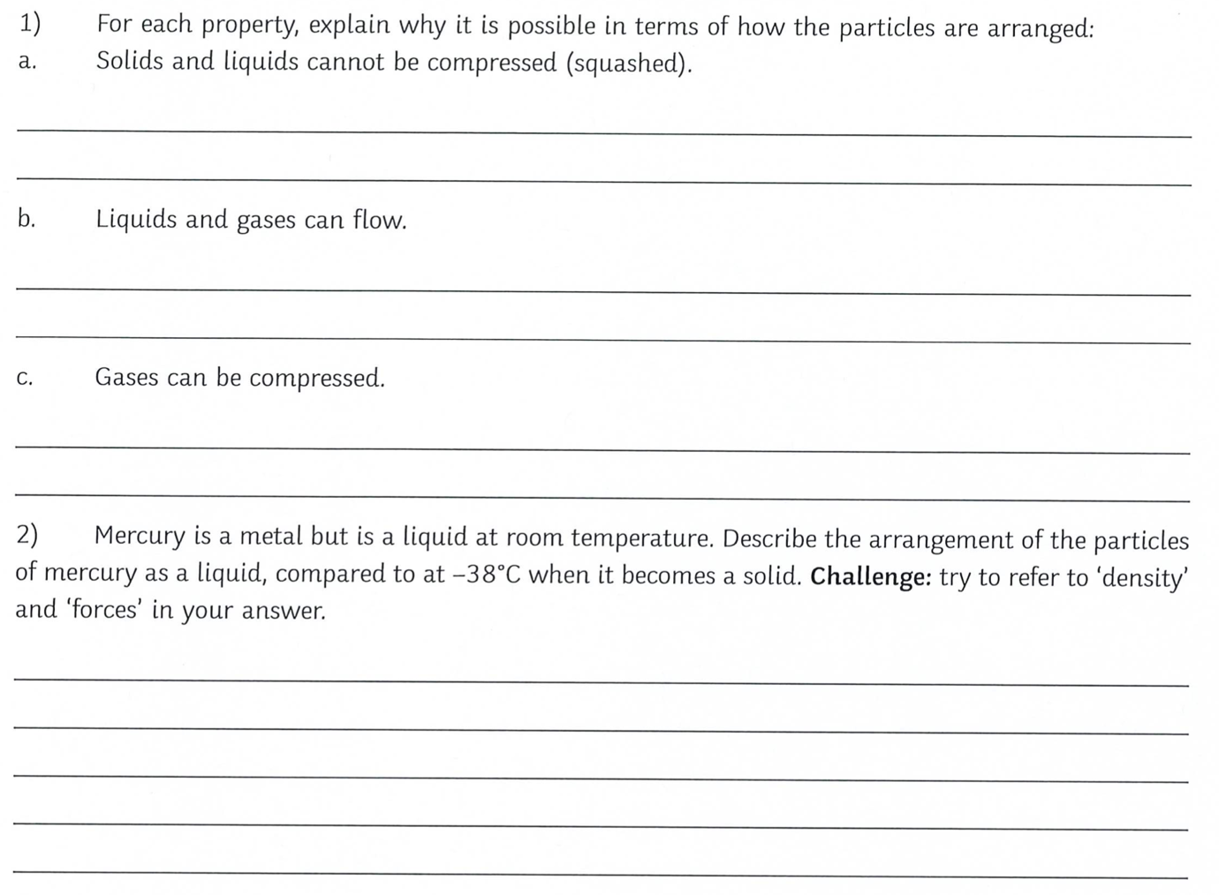
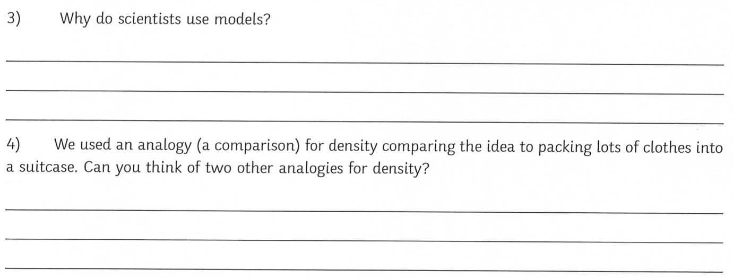
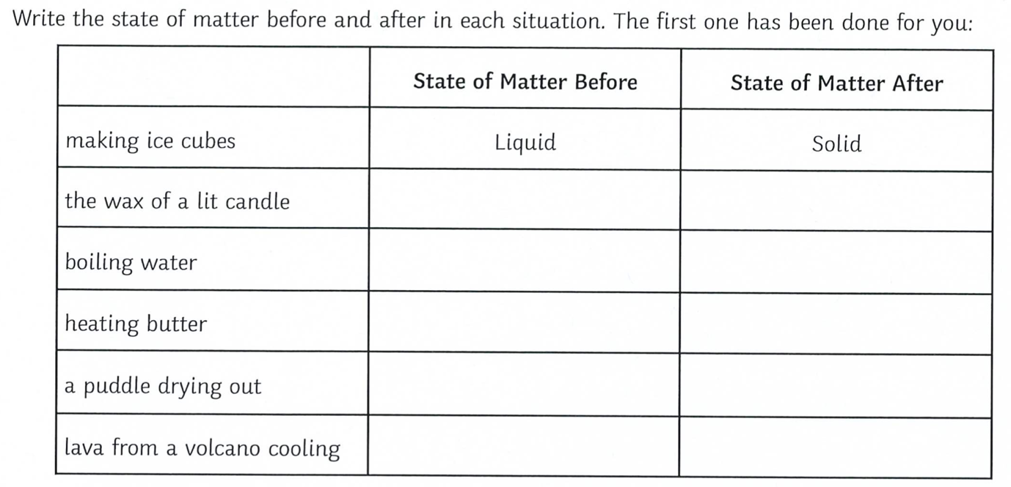
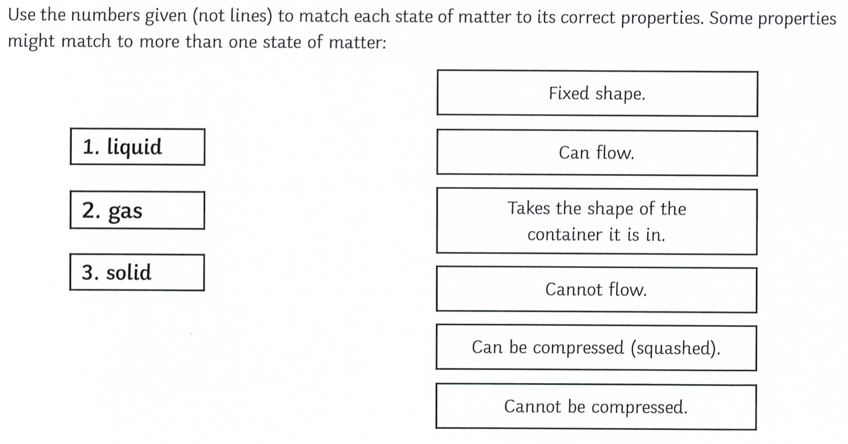

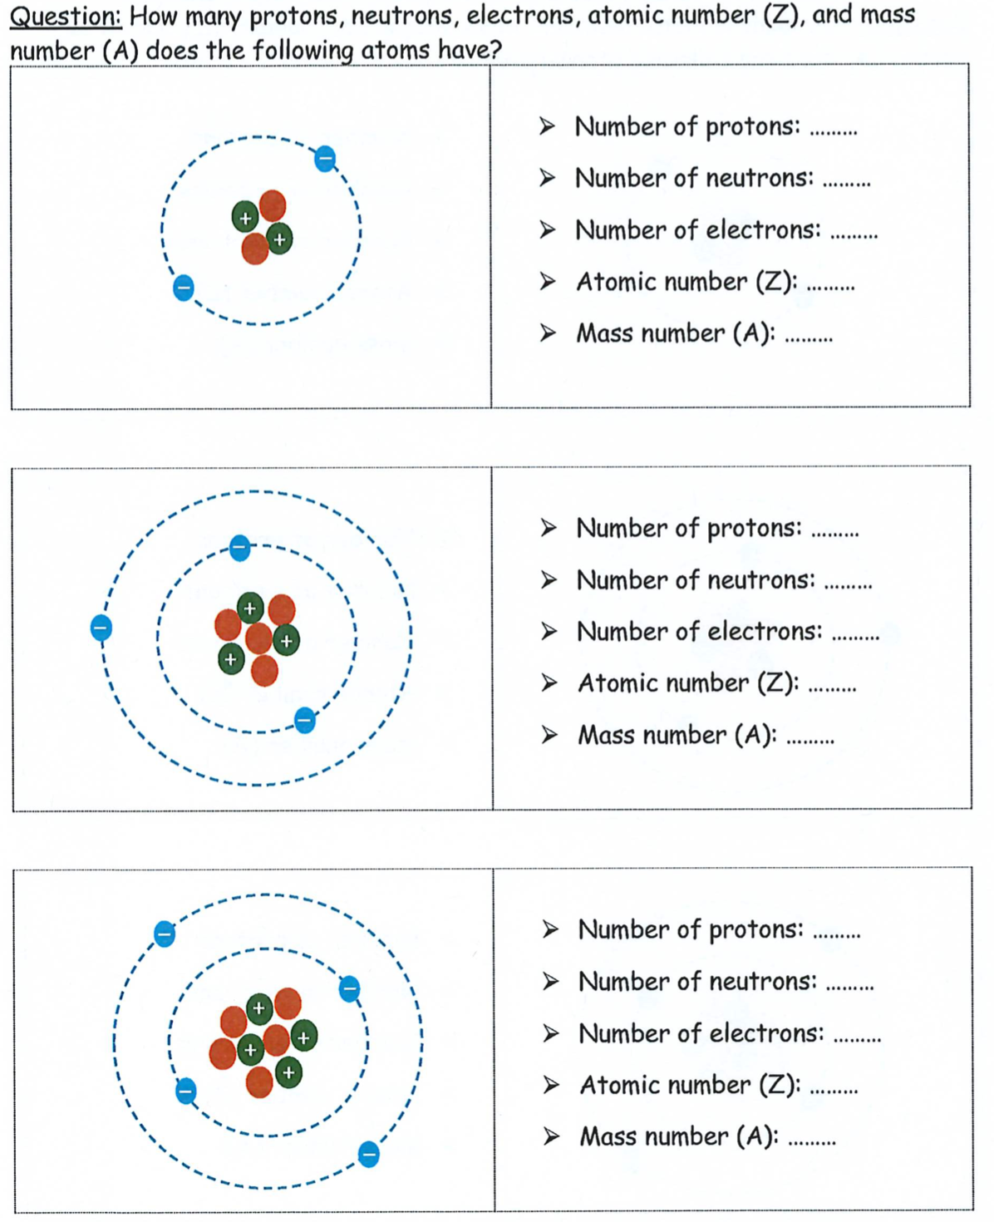

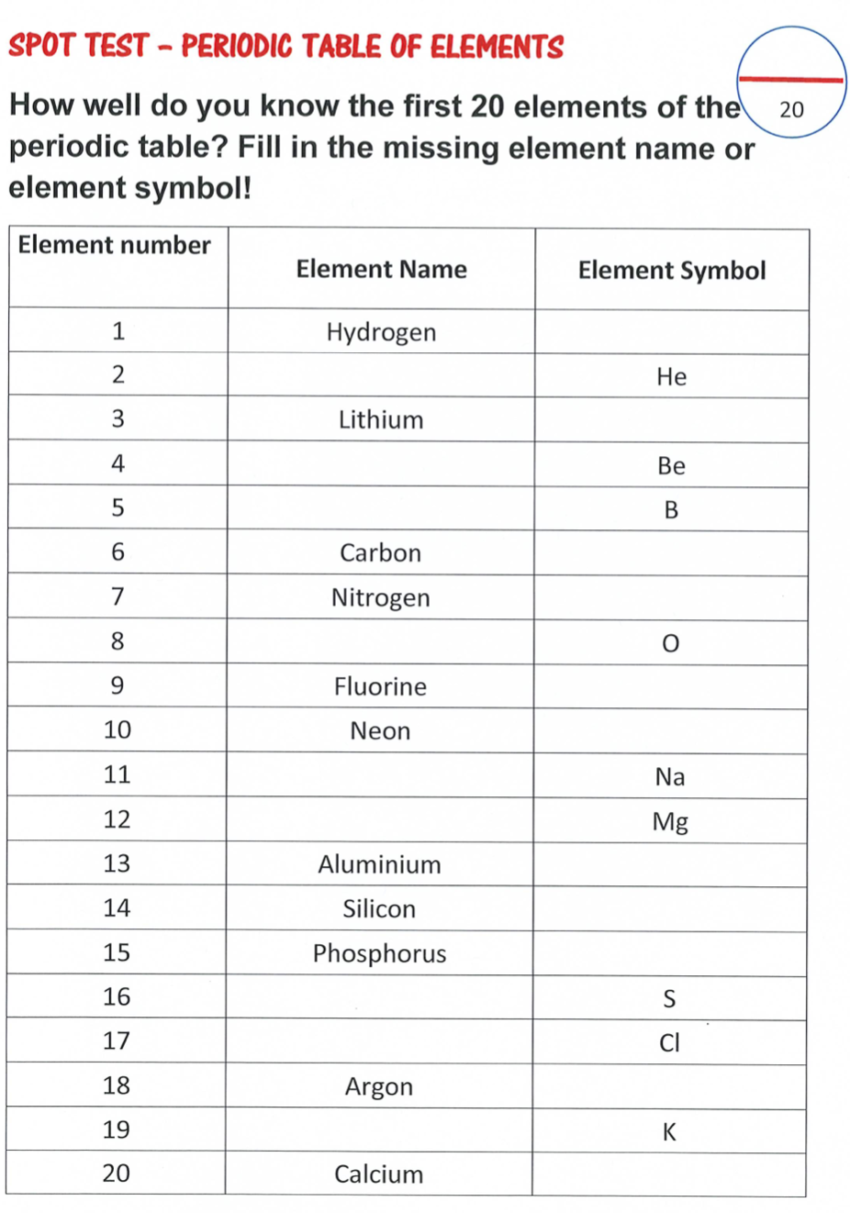
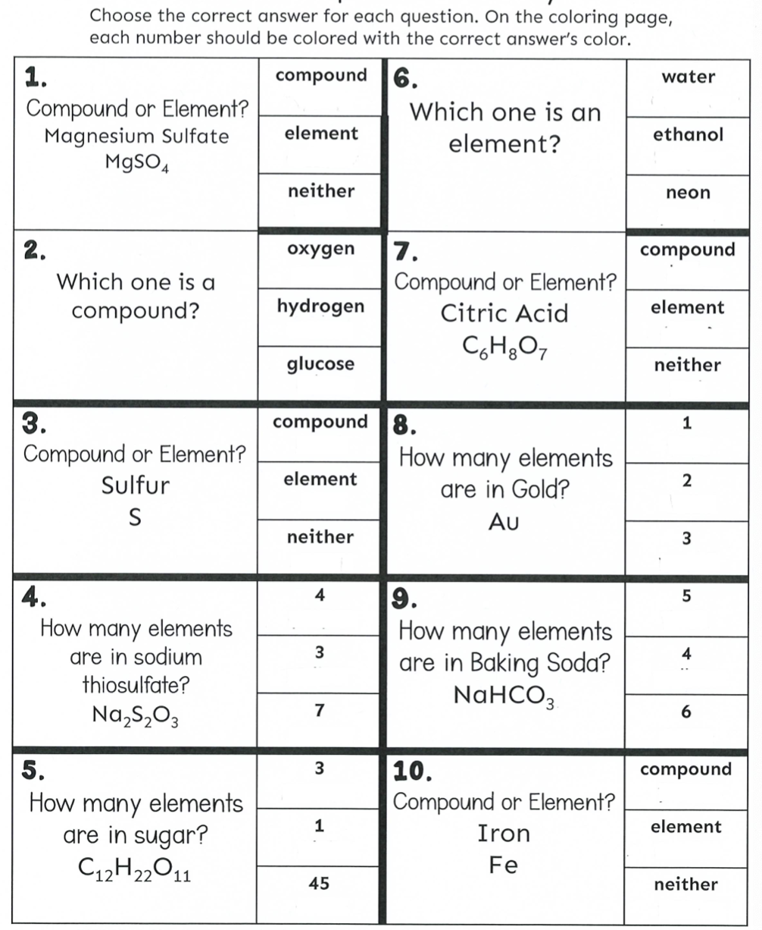
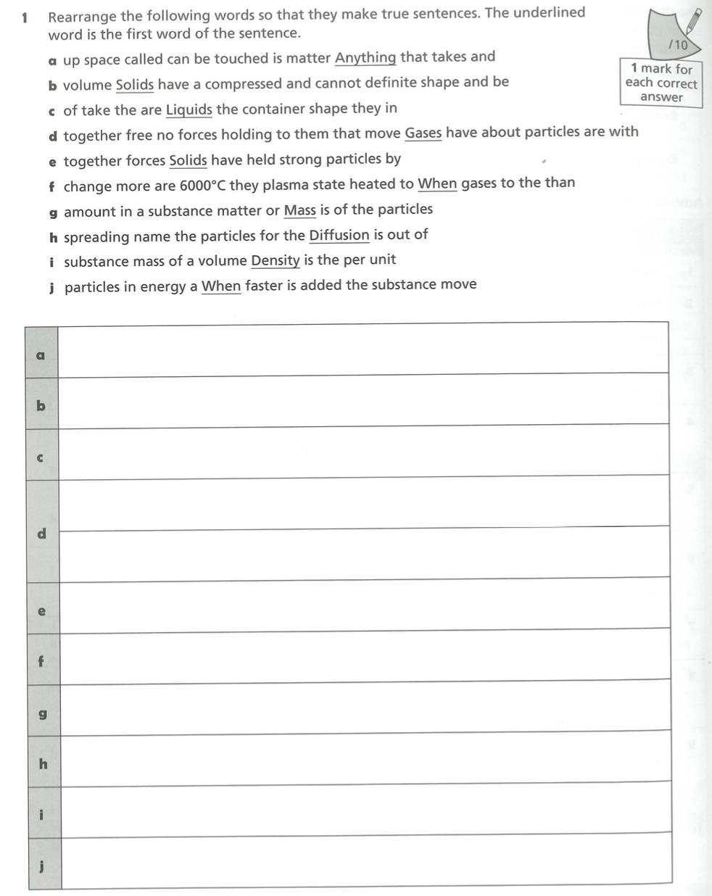

Elements, Compounds and Mixtures worksheet
- Which of the boxes contains:

- Molecules of an element?
- Molecules of a compound?
- Atoms of an element?
- Do any of the boxes contain a mixture? Explain your answer.
- Look at the following substances. Circle the elements and underline the compounds

- Li b) N₂ _{c) CO} _{d) Cl2} _{e)S8} _{f)NaCl}

- How many elements make up each compound?

- HCl b) CaCO₃ _{c) HNO3} _{d) H2}SO₄ _{e) CH3}OH

4. How many atoms are there in each of these molecules?
- N₂ _{b) CO2} _{c) O3} _{d) CH4} e) SO₂ _{f) C2}H₄
5. Circle the molecule with the most atoms, in each pair;
- HCl or POCl
- NH₃ or HNO₃
- C₃H₈ or C₂H₅OH
- CH₃COCH₃ or C₆H₆

